**Git Commands: Step By Step Guide (Part 1)**

we will go through basic Git commands step by step and see how to use in the project. Also, we will put the code in the cloud using [**GitHub**](https://github.com/techbrij/)**.** It is assumed Git is already installed and configured on your machine. I am using **Windows 10** for this post, but the same Git commands can be applied on [**Linux/Ubuntu**](https://techbrij.com/notes/linux-ubuntu-commands.php).

**1. To create a new local repository:**

Let’s create a directory for repository.

mkdir repo

cd repo

use following command to create repository

git init

It creates a **.git** directory that contains all the Git-related information for your project.

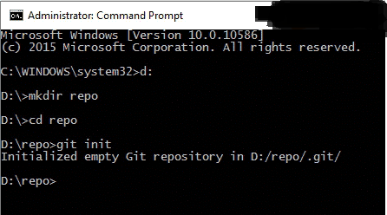

2. Create new file **file1.txt** and **file2.txt** in **repo** directory and run following command to check status.

git status

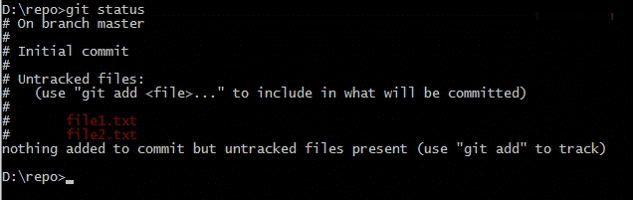

**Status** command displays a list the files you’ve changed and those you still need to add or commit.

**3. Adding files:**

Run following command to add both files:

git add file1.txt file2.txt

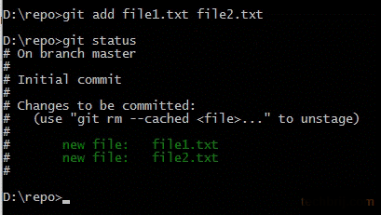

**Add** command adds one or more files to staging (index).

**4. Commit:**

After staging files, we can commit them into Git. Run following command to commit:

git commit -m "First commit"

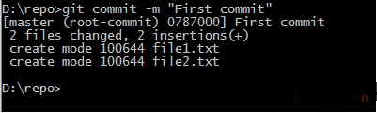

-m for commit message.

you can use -a to commit any files you’ve added with git add, and also commit any files you’ve changed since then.

git commit -a

**Note:** it is dangerous. let’s say you opened a file and changed it by mistake. if you add -a to your commit, all files would be committed and you would fail to notice possible errors.

You can use both -a and -m as well

git commit -am "My commit message"

**5. Further Commits:**

Let’s modify **file1.txt** after first commit. Now to check the changes from the last commit, run following command:

git diff

If you want to have a look at the changes to a particular file, you can run git diff <file>.  
Let’s commit the changes

git commit -am "Second commit"

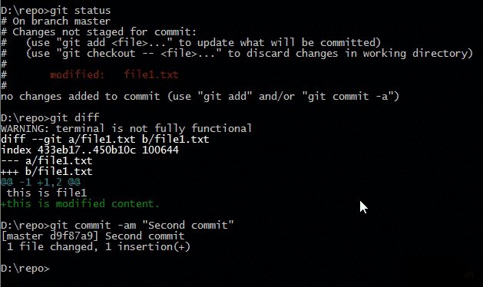

**6. To show log:**

To check the history of your project, run the following command:

git log

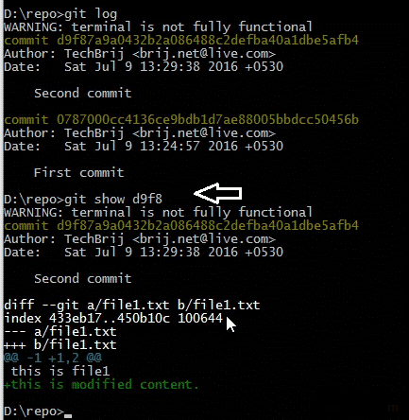

To view the details of a particular commit:

git show <hash>

Where <hash> is the hex number associated with the commit. you do not need to copy the whole string, and the first 5-6 characters are enough to identify your commit. As in the screenshot, only **d9f8** is used.

**7. To put code on remote server:**

You could create a project on **GitHub**, **GitLab**, or **BitBucket** and push your existing code to the repository. Conveniently, a remote to which you have write access is called the **origin**.

Run following commands to add a remote origin and then push the code to the origin.

git remote add origin https://github.com/techbrij/gitsample.git

git push -u origin master

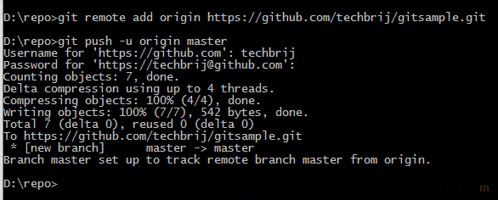

**Push** command is used to send changes to remote repository.